Sanbonmatsu Chaya Reservation



Sanbonmatsu Chaya Co., Ltd.

Website installation manual

By: Adri Firdiansyah Kaufmann

# List of contents

**List of contents 1**

**Getting Started 2**

**How to Install to localhost 2**

**How to Access Admin page and Customer page 3**

**Accessing 4**

**Admin page 4**

**Page explanation 4**

**Some Unfinished features/Bugs 6**

**Customer Page 7**

**Page Explanation 7**

**Some Unfinished features/Bugs 15**

# Getting Started

## How to Install to localhost

1. Extract the zip file that I uploaded on Microsoft Teams.
2. Visit this link <https://www.apachefriends.org/download.html> to download the XAMPP installation file.
3. Find the download for the Operating System that your computer uses and pick the newest version of XAMPP to download.
4. Install the XAMPP that you just downloaded.
5. Run the XAMPP application.
6. From the XAMPP control panel, start the services of Apache and MySQL by clicking the start buttons in the action column.
7. Open the Phpmyadmin control panel from your browser by putting this link “<http://localhost/phpmyadmin/>” (without quote) on the address bar or by clicking the “admin” button in the same row of MySQL on the XAMPP control panel.
8. Create a new database with the name “sanbonmatsu_reservation” (without quote) (The name of the database has to be exactly the same so that it won’t be needed to do anymore coding from the source file of the website) by clicking the “new” option from the left side panel of Phpmyadmin control panel.
9. After the database is created, click the database name on the left side panel of Phpmyadmin control panel to open it.
10. After clicking the database, go to import setting by clicking the “import” bar from the top navigation bar of Phpmyadmin control panel.
11. On the import page, click the “Choose file” button, open the “database” folder from the file that you extracted earlier and choose the file “sanbonmatsu_reservation.sql” and then scroll down and click the “import” button.
12. Open the file that you extracted earlier, copy the entire folder of “SanbonmatsuReservation”.
13. Go to “Windows(C:)”, open the “xampp” folder, open the “htdocs” folder, and then paste the “SanbonmatsuReservation” folder there.
14. Congratulation, the website has been installed in your computer.

## How to Access Admin page and Customer page

1. For ADMIN page, put the link <http://localhost/SanbonmatsuReservation/admin/> on the address bar of your browser.
2. For CUSTOMER page, put the link <http://localhost/SanbonmatsuReservation/> on the address bar of your browser.

(The recommended browser to use is Google Chrome)

# Accessing

## Admin page

### Page explanation

1. Login page

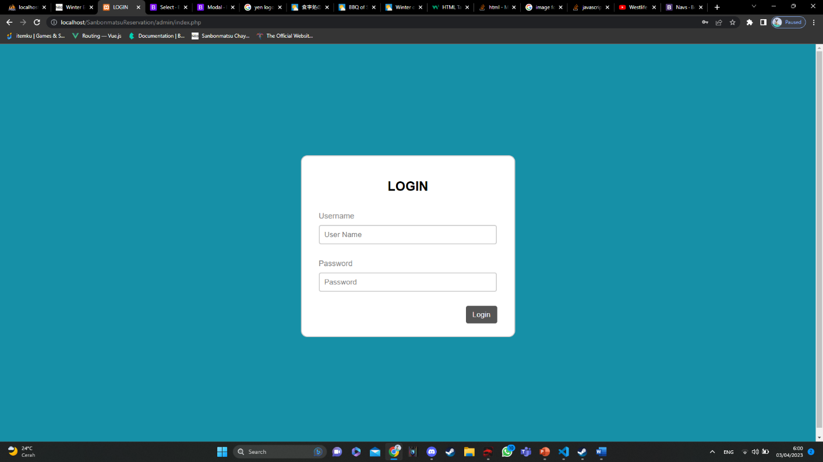

Picture 1. Admin Login page

This is the first page you are going to be directed after accessing the link that are given at the previous section for accessing the admin page. To access the other page of the admin website, you will need to login first. The username and password are the account data that stored in the “admin_table” from the “sanbonmatsu_reservation” database. The current account that is available to use is:

Username: kaufmann

Password: 12345678

For adding more admin account in the meantime we are unable to do it via the admin page because the feature for that has not been made yet, so if you are willing to add more admin account you need to do it via the Phpmyadmin control panel directly on the “admin_table” page and click the Insert option from the top navigation bar and fill all the form.

1. Side Navbar

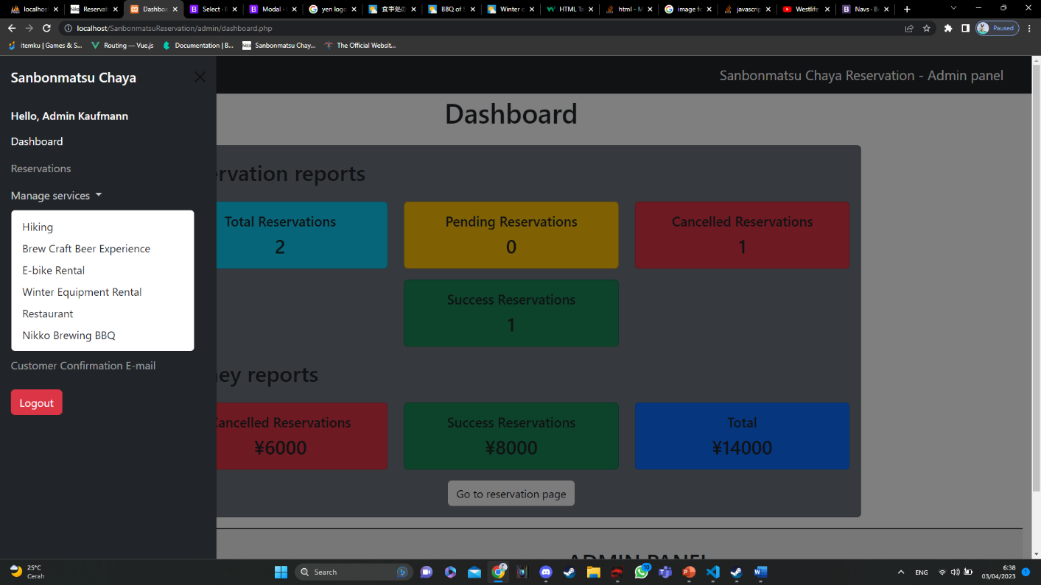

Picture 2. Side Navigation Bar

On the top left of the screen, you will see a hamburger Button if being clicked it will pop up a side navigation bar that contains The links to access all of the management pages available on the admin page and a logout button for the admin to end the login session.

1. Dashboard Page

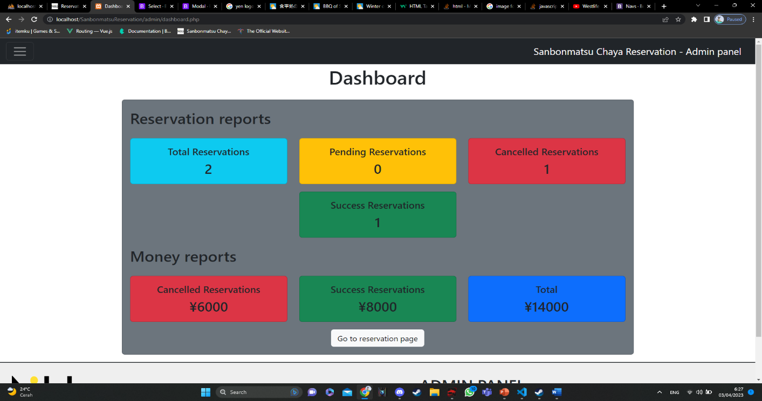

Picture 3. Dashboard page

On the Dashboard page, you will be shown the various cards of Reservation reports and Money reports. On the Reservation reports, the Total Reservations card will show you how many Reservations has been made, Pending Reservations card will show you how many reservations with the status of “Pending”(Not yet been paid by the customer), Cancelled Reservations card will show you how many reservations with the status of “Cancelled”(Has been paid by the customer but cancelled and refunded), and Success Reservation card will show you how many reservations with the status of “Success”(has been paid by the customer and not refunded). There is also a “Go to reservation page” to direct admin to the Reservation management page.

1. Item management page

You can add item and edit from the management page whether its for hiking, restaurant etc. all the item shown in the management page will be automatically shown in the customer end reservation page

### Some Unfinished features/Bugs

1. Live Search

The live search feature can’t work yet, so the search bar on each management page are still gimmicks.

1. Period of Reservation reports

Currently we cannot set to show the period of Reservation reports

1. Period of Money Report

Currently we cannot set to show the period of Money reports

## Customer Page

### Page Explanation

1. Reservation page

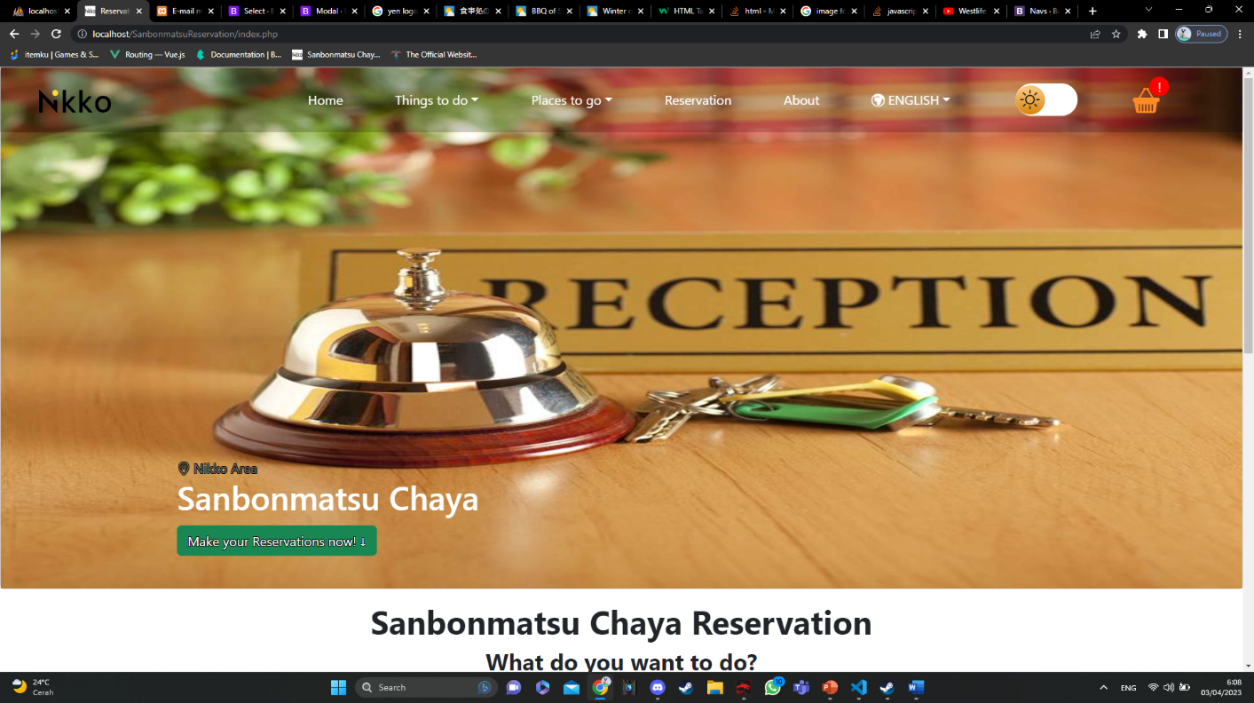

Picture 4. Reservation page

1. Experience based reservation

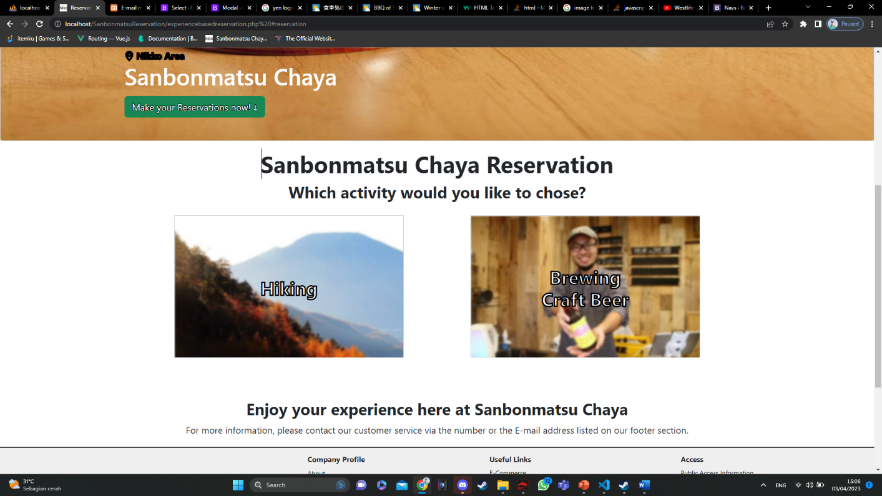

Picture 5. Experience based reservation

In Here we can choose to go to which experience based reservation page to browse and do the transaction. Each of those pages above already integrated with the admin system.

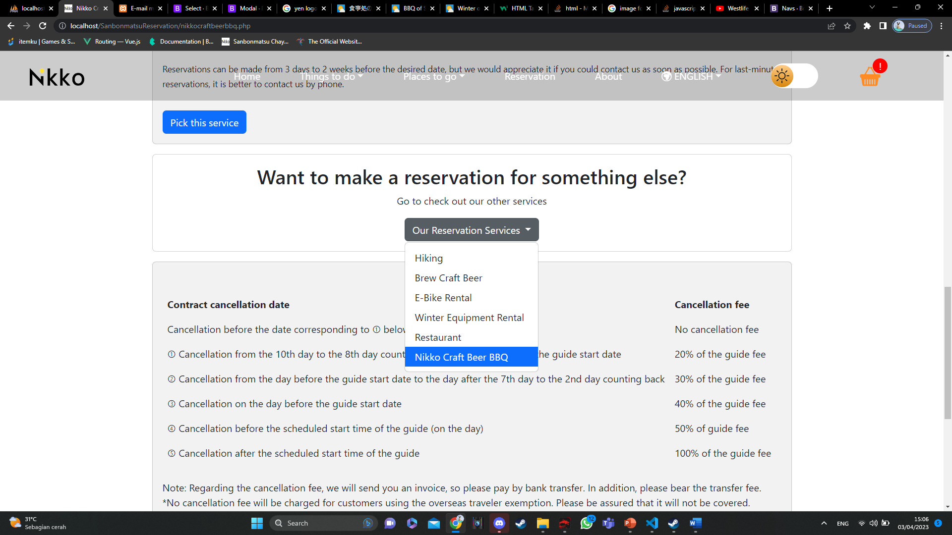

Picture 6. Mini page navigation

On Each reservation pages, we put the mini navigation to make the customer easier to access other reservation pages without them having to go through the first step.

1. Rental Based Reservation

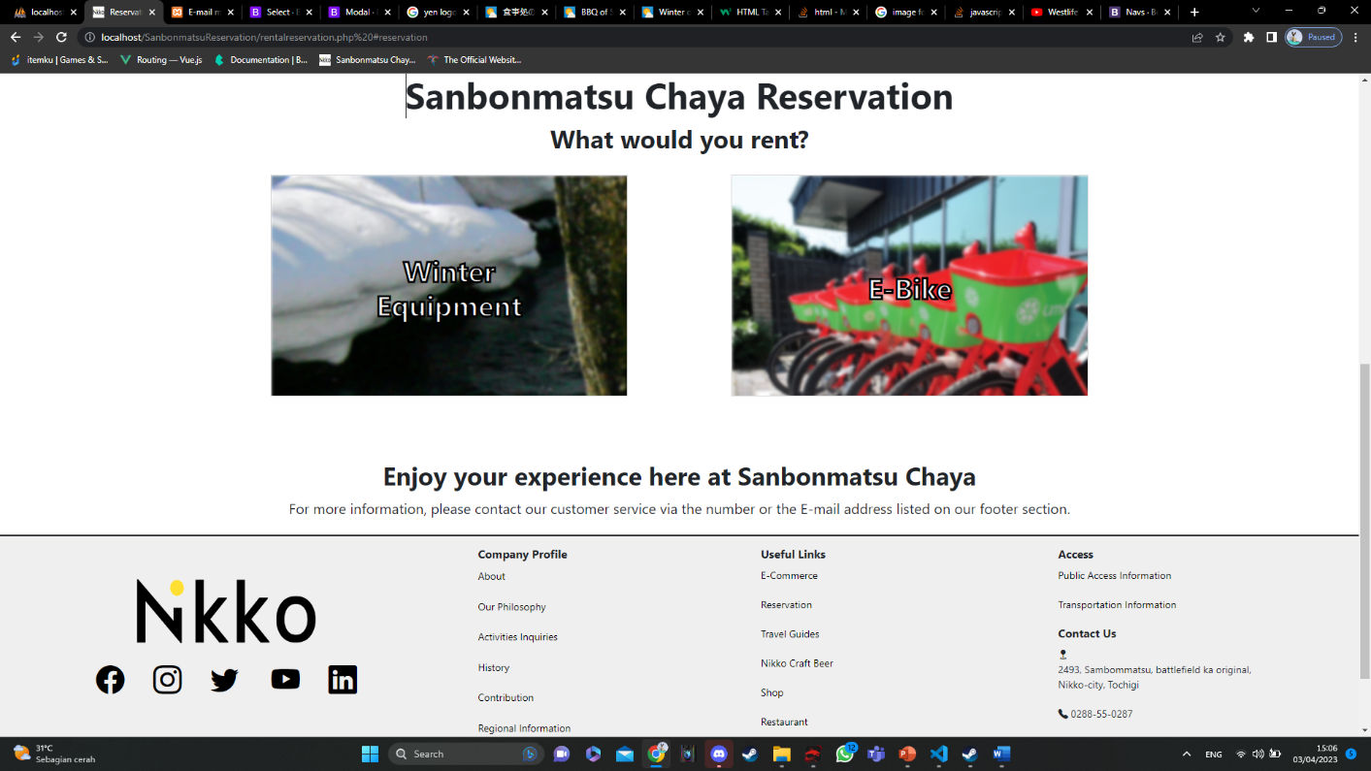

Picture 7. Rental based reservation

In Here we can choose to go to which Rental based reservation page to browse and do the transaction. Each of those pages above already integrated with the admin system.

1. Meal Based Reservation

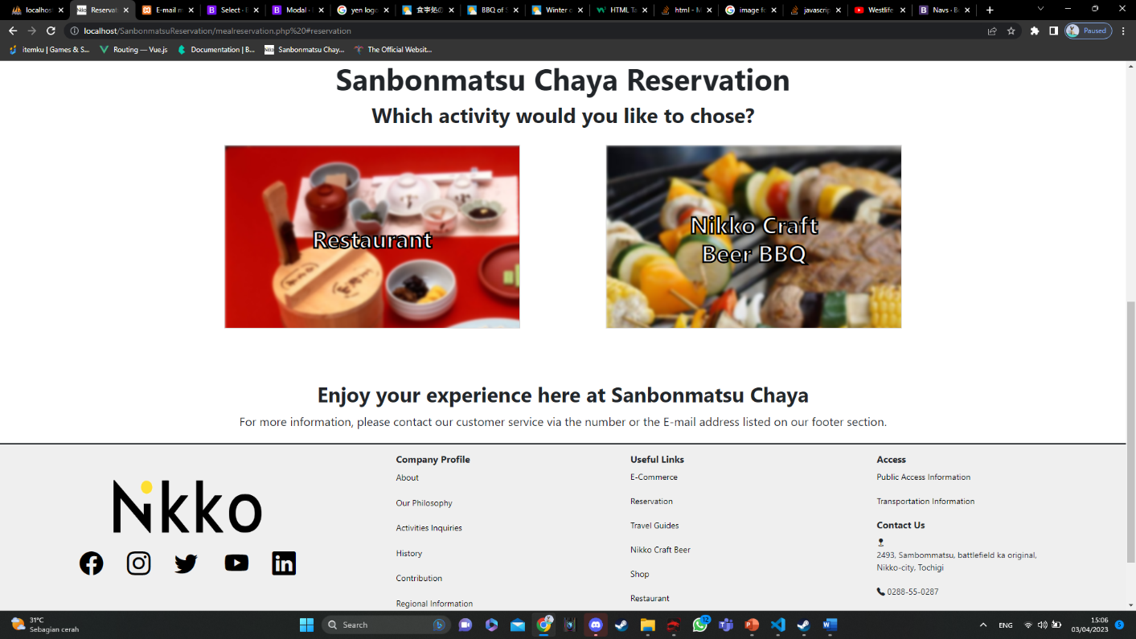

Picture 8. Meal based reservation

In Here we can choose to go to which Meal based reservation page to browse and do the transaction. Each of those pages above already integrated with the admin system.

1. Adding Reservation

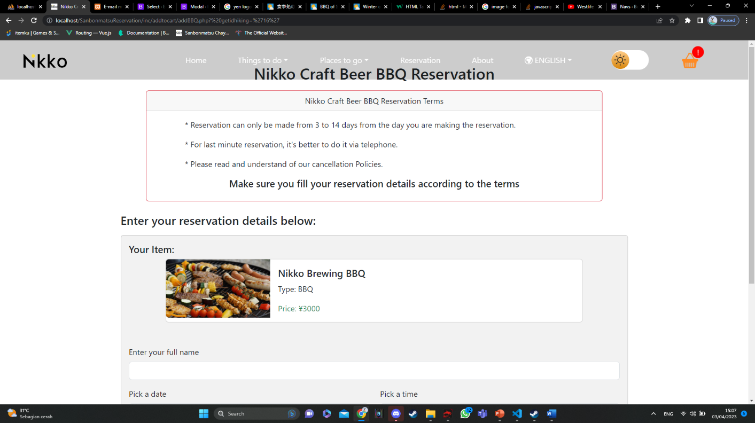

Picture 9. Add to cart page

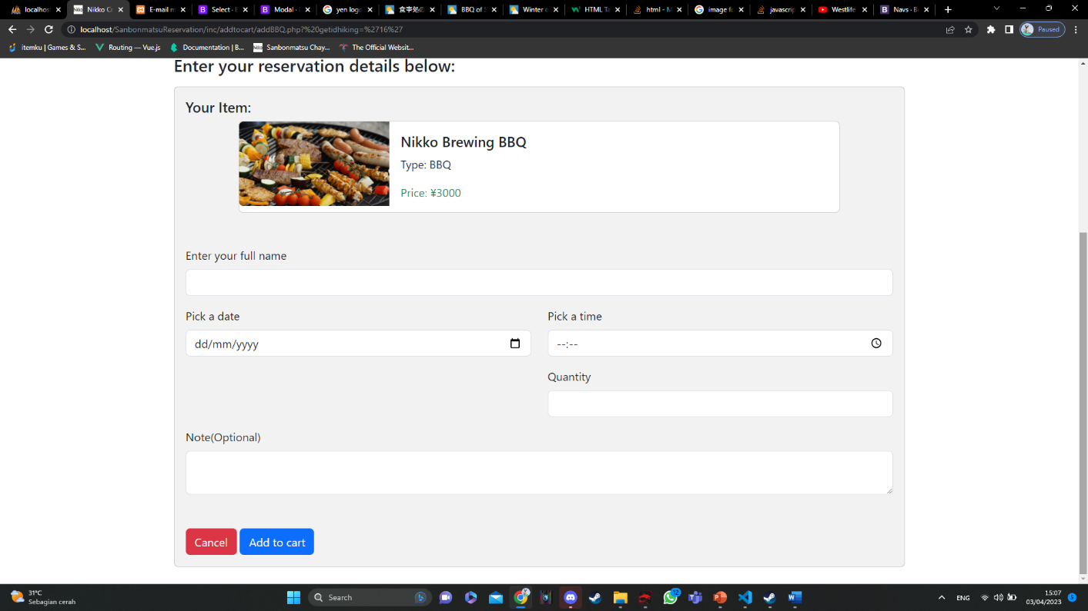

Picture 10. Add to cart page

When adding item to cart, Customer need to fill those forms, and make sure to write the saname Full name everytime they want to add new item to cart (To identify which item belong to whom because we do not require to have an account to make a reservation).

1. Cart Page

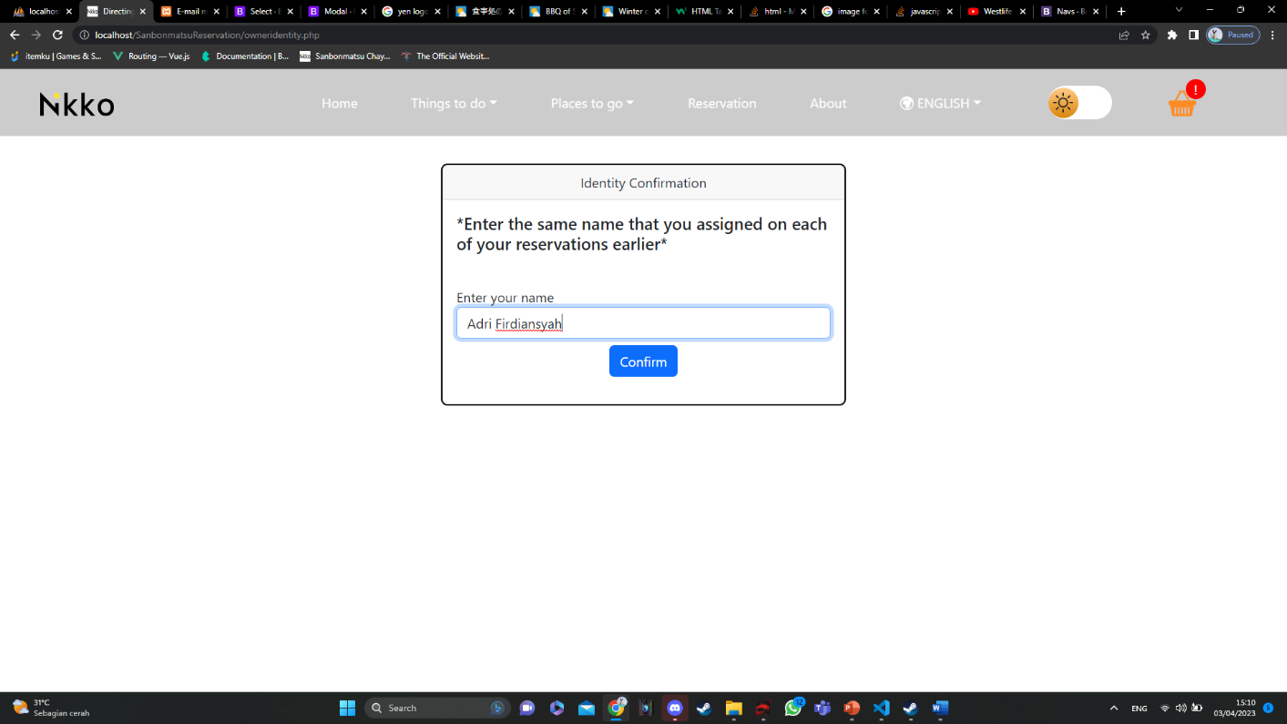

Picture 11. Owner Identity page

To access your own cart, you need to input your name to the form above and make sure the name is exactly the same as the one you filled on each of add to cart process.

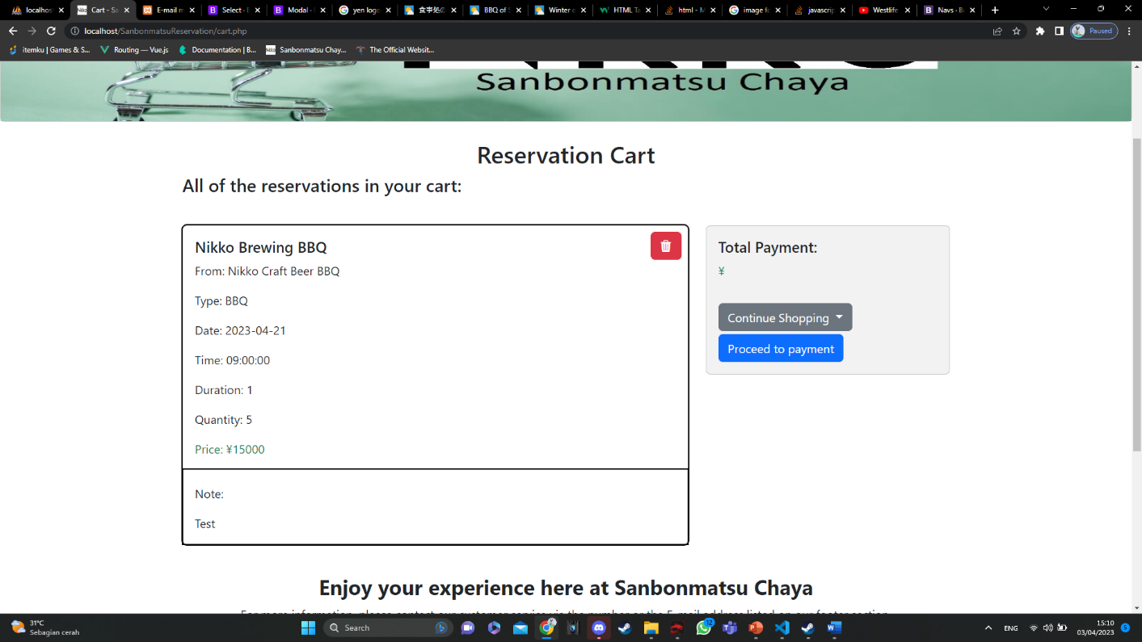

Picture 12. Cart page

If you entered the correct name during on the Owner Identity page and clicked the confirm button, you will be directed to the cart page and it will show you all of the item you’ve added to your cart.

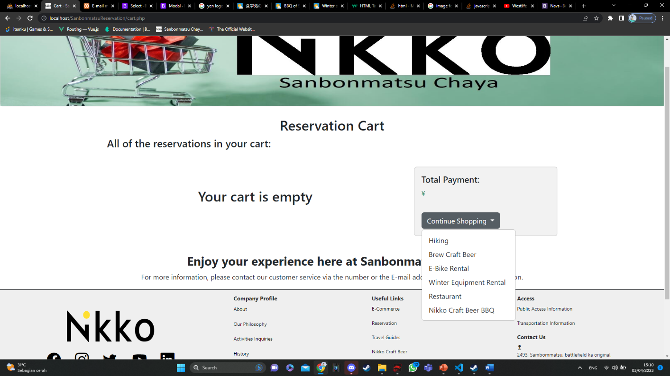

Picture 13. Cart page (empty cart)

If you entered the incorrect name during on the Owner Identity page and clicked the confirm button, you will be directed to the cart page and it will show you that your cart is still empty. Or This case will also happened if you have not adding any item to cart and you decided to open the cart page anyway.

1. Personal Identity form page

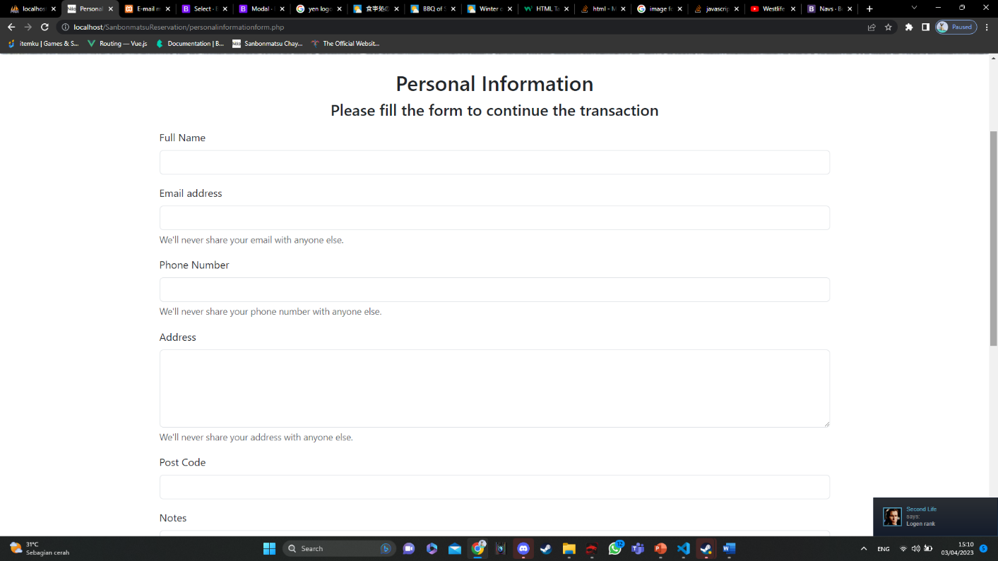

Picture 14. Personal Identity form

After the customer finished browsing items of the reservation page and decided to proceed the transaction by clicking the “Proceed to payment” button on the cart page, they will be directed to this page to fill out their personal identity.

1. Reservation Summary

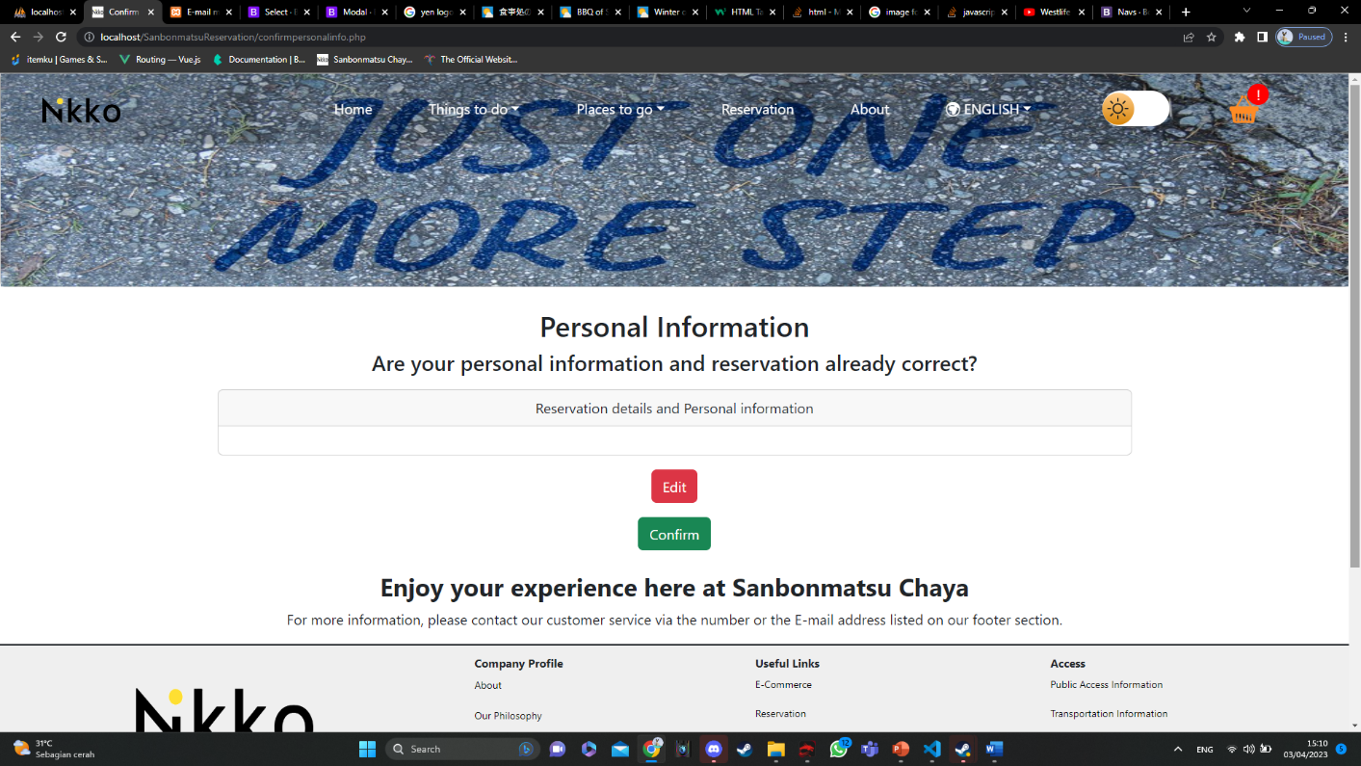

Picture 15. Personal Identity form

After the customer finished filling their personal identity, and click submit, they will be directed to the reservation summary where on there will be shown all of their personal contact, address, phone number and all of the item they are going to purchase. But I am very sorry to inform you that the feature is not working yet. My plan for this page is that after you clicked confirm, you will get a notification from e-mail about the details of your reservation.

### Some Unfinished features/Bugs

1. The feature only works until cart and identity form
2. E-mail confirmation is not working yet
3. Some of the winter equipment maybe still have some bugs